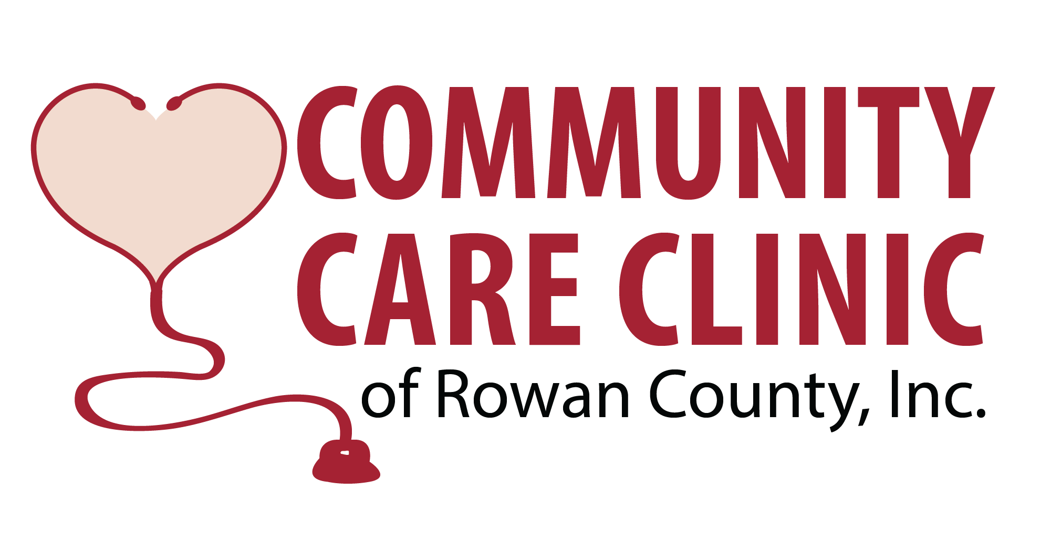
ELIGIBILITY REQUIREMENTS & DIRECTIONS FOR APPLICATION

ELIGIBILITY REQUIREMENTS:
- Patients must be an uninsured adult and a Rowan County resident.
- Patients cannot have a household income exceeding 250% of the Federal Poverty Level (currently $25,520 for individual and $52,400 for a family of four). Household income refers to the combined gross income of all members of a household, defined as a group of people living together, who are 15 years or older.

For Spanish speaking applicants: En este momento, no hay naconas personas en la clínica que puedan hablar español. Por eso, si estás aprobado por servicios, necesitarás traer tu propio traductor. Esto incluye todos las citas y todos los pasos del proceso de solicitud. Gracias por tu comprensión.

DIRECTIONS FOR APPLICATION:
- Complete the Application For Services and Patient Health History Form. If you are self-employed, you must also complete the Self-Employed Statement of Income Form. These forms can be returned at any time the clinic is open. Incomplete application forms may cause a delay in services. This Eligibility Requirements & Directions for Application Form explains the items to bring to the Enrollment Appointment for verification of eligibility.

- Your application will be reviewed by the clinic staff. Please be sure that you have given a current phone number at which you can be contacted. You should expect to hear from the clinic within 14 business days of completing your application. If you are approved, you will be scheduled for an Enrollment Appointment. During the Enrollment Appointment, you will not see a doctor.

- The following information must be brought to the Enrollment Appointment. Copies of the information below will be made and you will complete any other forms needed for your chart. Your paperwork will be processed and you will be enrolled as a patient. Upon completion, your first doctor’s appointment will be scheduled.

- SERVICES: It is the purpose of the Community Care Clinic of Rowan County to provide a high standard of care. The CCC is a primary care clinic and there will be limitations on services we can provide. The Board of Directors guides the clinic in the mission of providing the highest quality of patient care possible. The CCC does not offer services such as DOT physicals, disability evaluations, gynecology and/or pregnancy/STD testing.

Proof of income for patient Pay stubs for the last three months, verification from ESC for unemployment, monthly pension statement, letter from social security showing monthly benefit for retirement or SSI for dependent, child support, etc. Bank statement showing direct deposit cannot be used for proof of income. If you are applying for disability, we will need a letter of verification of claim from the Social Security Administration or letter from your lawyer.

Proof of income for other household members Household income refers to the combined gross income of all members of a household, defined as a group of people living together, who are 15 years or older. Pay stubs for the last three months, verification from ESC for unemployment, monthly pension statement, letter from social security showing monthly benefit for retirement or SSI for dependent, child support, etc. Bank statement showing direct deposit cannot be used for proof of income.

Income tax return If you filed taxes for the most recent tax year, we need either a copy of the 1040 or a transcript of you return. A transcript can be requested by calling 1-800-908-9946 or on-line at IRS.gov.

Proof of Identification & Residency ID - You will need a valid N.C. driver’s license or state identification card with a Rowan County address. You will also need to bring your social security card or a letter from the Social Security Administration with verified social security number. Residency - You will need to provide one recent document providing residency in Rowan County. Accepted documents include utility bill (gas, water, electricity) and/or rental or lease agreement.

Medicaid denial OR written statement from Social Services (Letter of Inquiry) stating you are not eligible for Medicaid less than 6 months old. If Social Services denies your Medicaid because you have not given them the information they requested, you must go back and complete the application before eligibility can be approved. If you have applied for Medicaid, but have not received an answer, we need proof of an application. We have included a letter that you can take with you to Social Services to apply for Medicaid.

The clinic requires a $10.00 non-refundable administrative fee per quarter. Patients can pay the $40 for the year or $10 per quarter. Patients who do not comply will be locked out and can unlock for $10 (max. one time per year).

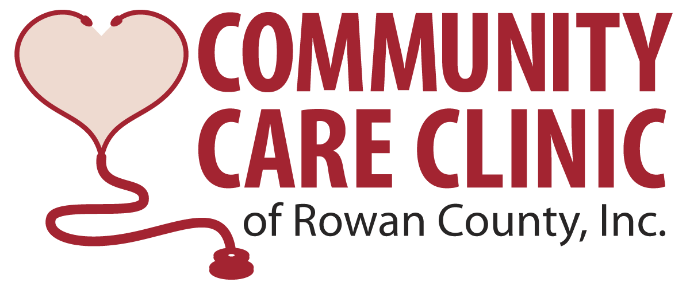

Please take this letter with you to the Department of Social Services in case there are questions regarding the paperwork you are requesting.

To Whom It May Concern:

In order to provide medications at no cost to patients at the Community Care Clinic, drug companies require documentation that the patient has either applied for, OR is not eligible for Medicaid. We request that all patients apply to determine if they may be eligible for benefits. If the patient does apply for benefits and is denied, we need a copy of the denial letter within 90 days of the initial visit to the clinic.

The Department of Social Services has requested that our patients provide the following information: two proofs of residency (utility bill, driver’s license) and proof of income (paycheck stubs – one month prior) to expedite this process.

If you need any further information, or have questions regarding required documentation, please feel free to contact me at 704-636-4523 ext. 201.

Sincerely,

Deborah Bailey
Office Manager

Office Use Only
Date submitted _____________________
1st Contact _____________________
2nd Contact _____________________
Enrollment Appt. ________________________
APPLICATION FOR SERVICES
(All forms must be completed before they will be reviewed for eligibility.)

Date: ______/______/______ Sex: □ M □ F Race: _________ Age: ______ Date of Birth: ______/______/_________
Marital Status: □ Married □ Single □ Separated □ Divorced □ Widowed □ Living with significant other
Name: _________________________________________________________________ SS# _______-_______-__________
Last First Middle Maiden
Are you a US citizen? □ Yes □ No Are you a legal resident? □ Yes □ No Are you a Rowan County resident? □ Yes □ No
Does the PATIENT speak English? □Yes □ No (If you answered no, it is unlikely that the clinic can provide services.)
Street Address ______________________________________ City _________________________ Zip _____________
Mailing Address ____________________________________ City _________________________ Zip _____________
Email Address ______________________________________________________________________________________
Best Contact Number** _______________________________**It is very important that we have a current phone number on file.
Next of Kin / Emergency Contact Name ______________________________________ Relationship __________________________
Emergency Contact Phone Number ______________________________________________________________________________
How did you hear about the clinic? _______________________________________________________________________________
Are you employed? □ Yes □ No Employer Name __________________________________________________
Did you file taxes? □ Yes □ No Are you claimed as a dependent on someone else’s taxes? □Yes □ No
Do you have any of the following?
Medicaid □ Yes □ No
Medicare □ Yes □ No
Medical insurance □ Yes □ No
Dental insurance □ Yes □ No
Are you eligible for VA benefits?
Medical □ Yes □ No
Dental □ Yes □ No
Prescription □ Yes □ No
Are you filing for disability? □ Yes □ No
Are you a veteran? □ Yes □ No
LIST TOTAL MONTHLY HOUSEHOLD INCOME AMOUNTS
Salary/wages _______ Disability _______
Social Security _______ Worker’s Comp _______
Unemployment _______ Self Employment _______
Pension _______ Other _______
# of adults in HH: _______
Office Use Only
ID ___
SS Card ___
Income ___
Taxes ___
Disability App ___
Medicaid Denial ___
Admin Fee ___
Proof of Residency ___
# of children in HH: _______
SERVICES REQUESTED
______I need to see a doctor at this clinic.
______I need to see a dentist at this clinic. Reason for needing to see a dentist:
□ Toothache □ Cavities □ Extraction □ Broken tooth □ Cleaning
The dental clinic does not provide dentures, partials, crowns, root canals or oral surgery.
If applying for medical and dental services, what is your immediate need? Medical or Dental (Circle one)

NOTE: The Community Care Clinic does not provide pain management or surgical services. If you need treatment for depression or mental health issues, contact Daymark Recovery Services at 704-633-3616. We do not prescribe narcotics or controlled medications (including Gabapentin). If these are your medical needs, it is highly unlikely that the Community Care Clinic will be able to serve you.

Applicant Signature ___________________________________________________________ Date ___________________________

PATIENT HEALTH HISTORY FORM

Name: ___________________________________________ Date: ___________________
Height: Weight: _________________
I Need Treatment For:
___ Diabetes Last blood sugar reading: ____________
___ High blood pressure Last blood pressure reading: __________
___ Heart problems ___ Thyroid
___ Hepatitis (liver disease) ___ Cholesterol
___ Other (Please list): _________________________________________________________

Other Health Conditions (Check all that apply):
___ Anemia ___Bronchitis ___Hearing loss
___ Angina ___Cataracts ___Ulcers
___ Arthritis ___Cirrhosis of the liver ___Kidney problems
___ Bladder infections ___Emphysema ___Seizures
___ Blindness ___Headaches ___Tuberculosis

Have you recently been in the hospital or visited the ER for any illness or injury? Yes ____ No___
Approximate Date Place Reason
___________________________________________________________________________________
Do you have a physician that you see regularly? Yes____ No_____
Physician Name and Phone Number ____________________________________________________
Do you have any food allergies? ________________________________________________________
Are you allergic to any medications that you know of? _____________________________________
What medications are you taking now, or should you be taking on a regular basis?
1. 4. ____________________________________
2. ______________________________________ 5. ____________________________________
3. ______________________________________ 6. ____________________________________

Are you currently being treated for depression or any other mental health disorder? Yes ___No ____

To best serve you, please answer to the best of your ability:

Do you smoke? Yes ____ No ____ How much per day? ___________________
Do you drink alcohol? Yes ____ No ____ How often? __________________________
Have you ever used street drugs? Yes ____ No ____ What type? __________ Last used? ______
Have you ever shared needles? Yes ____ No ____ Have you been tested for Hep C? _________
Do you have transportation? Yes ____ No ____ What type? __________
In the last year, have there been any major life changes (marriage, divorce, death of a loved one, illness or injury, financial struggles) that you would like to make us aware of? ______________________________________________

Dental Health Patient History
Rate your pain (Scale of 1 to 10). ________________________________________________________________
When was last time you saw a dentist? ________________________________________________________________ How often do you brush your teeth? __________________________________________________________________
How often do you floss? _____________________________________________________________________________ How often do you consume sugary drinks and how much? ________________________________________________ __________________________________________________________________________________________________

ALL INFORMATION DISCLOSED WILL BE KEPT CONFIDENTIAL

